5.6. Artificial Neural Network (ANN)
An Artificial Neural Network (ANN) is a computational model inspired by the structure and functioning of biological neural networks. It consists of interconnected processing units (neurons) that work together to solve complex problems like pattern recognition, classification, and data analysis.

5.6.1. Biological Inspiration
- Neurons in the Human Brain: The brain consists of billions of neurons connected through synapses. Each neuron processes information and transmits it to other neurons.
- Synaptic Learning: Learning occurs through the adjustment of synaptic weights based on experiences (Hebbian learning).
- Parallel Processing: The human brain processes multiple inputs simultaneously, allowing for efficient learning and decision-making.
- Artificial Neurons vs. Biological Neurons: ANNs mimic biological neurons using mathematical models to simulate learning and adaptation.

5.6.2. Basic Components of ANN
- Neuron (Perceptron): The fundamental unit of an ANN, which processes inputs and produces an output based on activation functions.
- Layers of ANN:
  - Input Layer: Receives raw data (features).
  - Hidden Layers: Perform complex computations and pattern extraction.
  - Output Layer: Produces the final decision or classification.
- Weights and Biases: Adjustable parameters that influence how inputs are processed and transformed.
- Activation Functions: Determines how the weighted sum of inputs is transformed into an output. Common activation functions include:
  - Sigmoid: Used for probability-based outputs.
  - ReLU (Rectified Linear Unit): Helps prevent vanishing gradient issues.
  - Tanh (Hyperbolic Tangent): Scales values between -1 and 1.
- Training Process:
  - Forward Propagation: Computes the output by passing inputs through layers.
  - Loss Function: Measures the error between predicted and actual output.
  - Backpropagation: Adjusts weights using optimization techniques like Gradient Descent.
5.6.3. Training Neural Networks
Training a neural network involves adjusting its parameters (weights and biases) to minimize the error between predicted and actual outputs. This process includes forward propagation, computing a loss function, and updating weights using backward propagation and optimization techniques.

5.6.3.1. Forward Propagation
Forward propagation is the process by which input data moves through the network layer by layer to generate an output. The steps include:
- Input Layer Processing: Receives raw data (features) and passes them to the next layer.
- Weighted Sum Calculation: Each neuron applies weights and biases to incoming inputs.
- Activation Function: Applies a nonlinear function to introduce non-linearity and determine neuron activation.
- Output Layer: Produces the final prediction (classification, regression, etc.).

5.6.3.2. Loss Function
A loss function quantifies the difference between the predicted output and the actual target. The goal is to minimize this loss during training. Common loss functions include:
- Mean Squared Error (MSE): Used for regression problems.

- 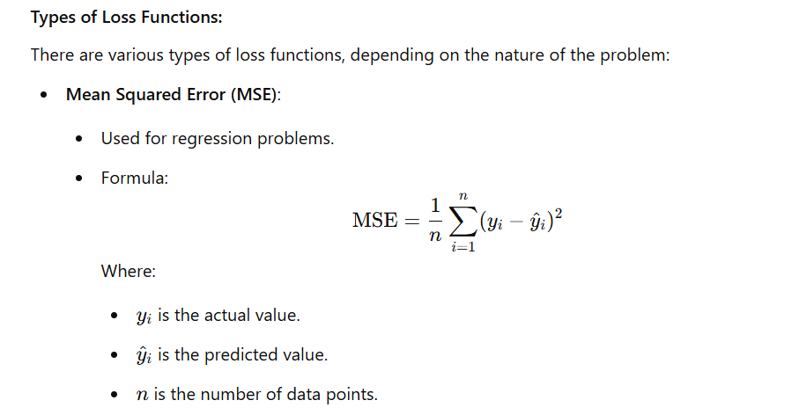Cross-Entropy Loss: Used for classification problems.
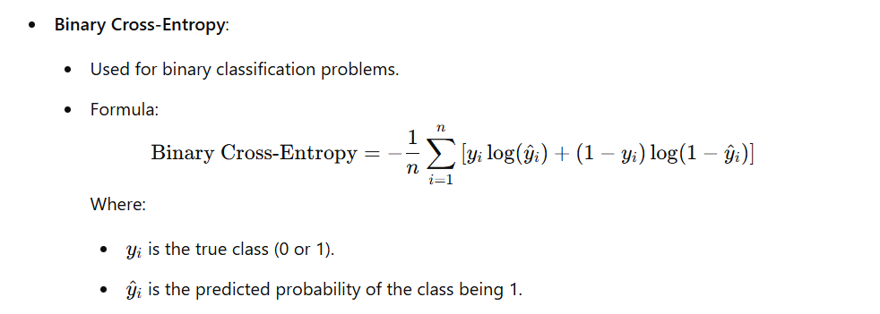

5.6.3.3. Backward Propagation
Backward propagation (backpropagation) is the process of updating weights to minimize the loss function. It follows these steps:
- Compute Gradient of Loss Function: Measures how much each weight contributes to the error.
- Gradient Descent Optimization: Updates weights in the opposite direction of the gradient to reduce error. .
- Chain Rule Application: Calculates gradients layer by layer using the chain rule of calculus.
- Weight Adjustment: Modifies weights iteratively to minimize loss.

=)Most prominent advantages of Backpropagation are:
Back propagation is fast, simple and easy to program
It has no parameters to tune apart from the numbers of input
It is a flexible method as it does not require prior knowledge about the network
It is a standard method that generally works well
It does not need any special mention of the features of the function to be learned.

5.6.3.4. Learning Rate
The learning rate (η\etaη) controls the step size for updating weights. Choosing the right learning rate is crucial for efficient training:
- High Learning Rate: Speeds up convergence but risks overshooting the optimal solution.
- Low Learning Rate: Ensures stability but may slow down training.
- Adaptive Learning Rate Methods:
  - Adam (Adaptive Moment Estimation)
  - RMSprop (Root Mean Square Propagation)
  - AdaGrad (Adaptive Gradient Algorithm)

5.6.4. Single-Layer Perceptron
A Single-Layer Perceptron (SLP) is the simplest type of artificial neural network consisting of only an input layer and an output layer. It is primarily used for linear classification problems.
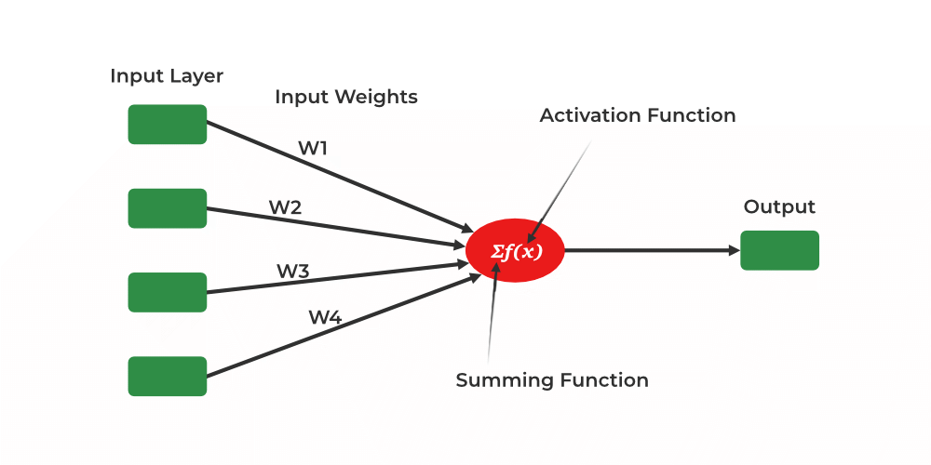

Characteristics of Single-Layer Perceptron:
- Contains a single layer of neurons that directly map inputs to outputs.
- Uses a weighted sum of inputs and applies an activation function to determine the output.
- Suitable only for linearly separable problems (e.g., AND, OR logic gates).
- Cannot solve complex problems like XOR, which require non-linearity.

Training Algorithm:
- Initialize weights and bias randomly.
- Compute the weighted sum of inputs.
- Apply an activation function (e.g., step function).
- Update weights using the perceptron learning rule:
- Repeat until convergence.

Limitations of SLP:
- Can only classify linearly separable data.
- Fails to handle complex relationships (e.g., XOR problem).

5.6.5. Multi-Layer Perceptron (MLP)
A Multi-Layer Perceptron (MLP) is an advanced version of SLP that contains one or more hidden layers, enabling it to solve non-linear problems.
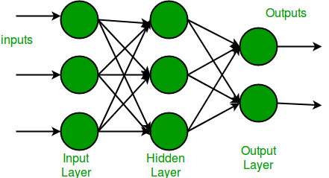

Characteristics of MLP:
- Composed of an input layer, hidden layers, and output layer.
- Uses activation functions like ReLU, Sigmoid, or Tanh to introduce non-linearity.
- Trained using backpropagation and gradient descent.
- Suitable for complex problems such as image recognition, speech processing, and financial forecasting.

Structure of MLP:
- Input Layer: Receives the input features.
- Hidden Layers: Perform feature transformation and learning.
- Output Layer: Provides the final decision.

Training Process:
- Forward Propagation: Computes output from inputs.
- Loss Computation: Measures the difference between predicted and actual values.
- Backward Propagation: Adjusts weights to minimize the error.
- Weight Update: Uses optimization techniques like SGD (Stochastic Gradient Descent), Adam, or RMSprop.

Advantages of MLP:
- Can learn complex, non-linear relationships.
- Works well with large datasets and multiple features.
- Can solve problems like XOR classification

